**Program 17: Demonstrate the use of Exception handling keyword try ,except,raise and else.**

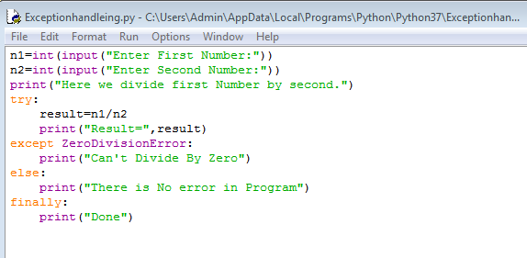

**Output:**

